K2 – VENTURES INSTANT PAY WEB APPLICATION

SRS Document

By Bhushan Shah

Table of Contents

Version Controls - 4 -

1. Executive Summary - 5 -

1.1. Project Overview - 5 -

1.2. Purpose and Scope of the Functional Requirement Document - 5 -

1.2.1. Intended Users of Application: - 5 -

1.2.2. In Scope: - 5 -

1.2.3. Out of Scope - 6 -

2. Introduction - 6 -

2.1. Application Modules - 6 -

2.2. End Customer User Module High-level Features - 6 -

2.3. Merchant Modules - 7 -

2.4. Instant Pay Administrator Modules - 7 -

2.5. Integrations - 7 -

3. Administrator (K2 Venture Users): Web Interface Functionality - 7 -

3.1. Admin Interface Login Workflow: - 8 -

3.2. Admin Interface Login Process Flow: - 8 -

3.3. Admin Interface Create Internal Users Workflow: - 10 -

3.4. Admin Interface Create Internal Users Process flow: - 10 -

3.5. Admin Interface Add New Role Workflow: - 12 -

3.6. Admin Interface Add New Role Process flow: - 12 -

3.7. End User Management Tab Workflow - 14 -

3.8. End User Management Tab Process Flow - 14 -

3.9. Merchant Management Tab Workflow - 16 -

3.10. Merchant Management Tab Process Flow - 17 -

3.11. Settings Panel - 19 -

3.11.1. Split Payment Management - 19 -

3.11.2. Payment Management - 20 -

3.11.3. Subscription Management - 21 -

3.11.4. Alert Template Management - 21 -

3.11.5. Content Management - 22 -

3.12. Notification Bell Icon - 23 -

3.13. User Profile - 23 -

3.14. Logout - 23 -

4. End Customer Front-end: User Interface Functionality - 24 -

4.1. End Customer Registration Workflow - 24 -

4.2. End Customer Register Process Flow - 24 -

4.3. End Customer Login and Forget Password Workflow - 26 -

4.4. Login - 26 -

4.4.1. Forget Password: - 26 -

4.5. User Dashboard - 27 -

4.5.1. Data Display Cards: - 27 -

4.5.2. Data Grid: - 27 -

4.5.3. Transaction Detail Information: - 27 -

4.6. Payment Method Setup - 28 -

~~4.7.~~ ~~Transaction Page~~ - 29 -

~~4.7.1.~~ ~~Transaction Detail Page~~ - 30 -

4.8. Notification - 30 -

4.9. My Profile - 31 -

4.10. Logout - 31 -

4.11. Footer Links - 32 -

5. Merchant Front-end: Marketing Landing Page - 32 -

5.1. Merchant Registration Workflow - 33 -

5.2. Register / Sign In - 33 -

5.3. API Information - 34 -

5.4. Product Information Page - 34 -

5.5. Contact Us Page - 34 -

5.6. Footer Links - 34 -

6. Merchant Back-end: Merchant Web Interface - 34 -

6.1. Merchant Login and Forget Password Workflow - 35 -

6.2. Login - 35 -

6.2.1. Forget Password: - 35 -

6.3. My Profile - 36 -

6.4. Merchant Dashboard - 36 -

6.5. Transaction History - 37 -

6.6. Merchant Interface Create Internal Users Process flow: - 38 -

6.7. Merchant Interface Add New Role Process flow: - 39 -

6.8. Sales Reports - 40 -

6.9. Merchant Subscription Plan Workflow - 41 -

6.10. Subscription - 41 -

6.11. Notification - 42 -

6.12. Footer Links - 43 -

7. End Customer Check-Out process from Merchant Online Portals - 43 -

7.1. Instant Pay One Click Payment Option Workflow By End Customer - 44 -

7.2. Instant Pay One Click Payment Option Process Flow By End Customer - 44 -

7.3. Instant Pay Split Payment Option Workflow by End Customer - 45 -

7.4. Instant Pay Split Payment Option Process flow by End Customer - 46 -

8. Scheduled Jobs - 47 -

8.1. Scheduled Payment Authorization Flow - 47 -

8.2. Scheduled Instalment Payment Flow - 47 -

9. Marvel Links - 48 -

9.1. Instant Pay Admin Screens - 48 -

9.2. Merchant Screens - 51 -

9.3. End Customer Screens - 52 -

9.4. End Customer Payment Through Merchant Portal Screens - 53 -

# Version Controls

|  |  |  |  |
| --- | --- | --- | --- |
| Version | Section Changes and Additions | Changes Done By | Date Modified |
| 1.0 | Instant Pay Admin Interface | Bhushan Shah | 19-10-20 |
| 1.1 | End User and Merchant Frontend and Backend Features | Bhushan Shah | 21-10-20 |
| 1.2 | Admin wireframes links added | Chetan Kokal | 23-10-20 |
| 1.3 | Added Merchant Checkout Features in 7,8 and Added Create user in Merchant in 6.5, 6.6 | Bhushan Shah | 26-10-20 |
| 1.4 | Merchant and User wireframes links added | Chetan Kokal | 29-10-20 |
| 1.5 | Added New Workflows added Section 9 | Bhushan Shah | 30-10-20 |
| 1.6 | Strikethrough texts needs to be out of scope and made changes to process flow as discussed with K2 team on 30-10-20 | Bhushan Shah | 31-10-20 |

# Executive Summary

## Project Overview

K2 Ventures is looking to design and develop an application which will facilitate the feature of One Click payment option for its registered users utilizing the platform to process online payments for their purchases from the Merchant websites who are also the subscribed members of the K2 Venture Instant Pay platform. The is aimed towards development of Web interfaces for the 3 categories of users the K2 Venture Users, Merchants and the End Customers or Purchaser.

## Purpose and Scope of the Functional Requirement Document

The purpose of this document is to describe business requirements of the Web application completely, accurately and unambiguously in Technology-independent manner. All attempts have been made in using mostly business terminology and business language while describing the requirements in this document. The document will contain a detail application workflow for the different interfaces and the user group who shall be using this application

## Intended Users of Application:

Following are key user roles for application,

* K2 Venture Instant Pay Admin Users
* Merchant Users
* End Customer Users

## In Scope:

The scope of work includes Designing, developing and testing of Web Application for Merchants and Customers along with development of Admin panel for Instant Pay Web application.

Primary Features Included are:

Web based interface for the Merchants and Users to manage their account details and transactional information and subscriptions for the merchant subscribers and end client users

A Web based interface for the K2 venture Admin users to manage the Merchant Client and end Users Customer records along with the Payment Gateway APIs management and Subscription Managements from the backend

Third Party Integrations:

SMS Gateway

Email Integration

Google Analytics

Third Party Payment Gateway

## Out of Scope

Application Content Including:

Text

Images

Videos

Graphical Data

Logo

# Introduction

The Instant Pay Application is designed and developed to simplify the online payment process for a user who is given the ease to checkout using the Payment process provided by Instant Pay with a single click. User will also have the option to choose between onetime full payment and spilt payment option which will ease on large amount purchases as a part of the payment facility. The application will cater to various online businesses and vendors who would be willing to subscribe for the Instant Pay checkout facility as a part of their online Payment Gateway options for their customers. Instant Pay platform can provide a secured way to maintain and store financial information for payment in a secured vault which can be fetched with the consent of the user for process a quick payment across multiple vendor platforms who are subscribed to the Instant Pay payment facility. The application will also provide integrated payment forms that can be embedded in the Merchant platform to ensure that the customers of the merchants are provided the ease of checkout with one click.

## Application Modules

The application is divided into three major modules which is User Module, Merchant Module and the Instant Pay Admin User Modules

## End Customer User Module High-level Features

* Sign Up
* Login
* Headers
* User Dashboard
* Payment Page
* Transaction Page
* Notifications
* My Profile
* Logout
* Footer

## Merchant Modules

* Merchant (Front-End: Marketing Interface)
* Header
* Home
* Product Information
* My Account
* My Profile
* Contact Us
* Merchant (Front-End: Merchant Interface)
* Log In
* Merchant Dashboard
* Payment History
* Sales Reports
* Subscription
* Notifications
* My Profile
* Logout

## Instant Pay Administrator Modules

* Login
* Dashboard
* User Management
* Merchants Management
* Payment Management
* Subscription Management
* Content Management
* Email & Notifications Template Management
* Header & Footer Management
* Roles & Permission
* Settings
* Logout

## Integrations

* SMS Gateway
* Google Analytics
* Email Integration
* Payment Gateway

# Administrator (K2 Venture Users): Web Interface Functionality

## Admin Interface Login Workflow:

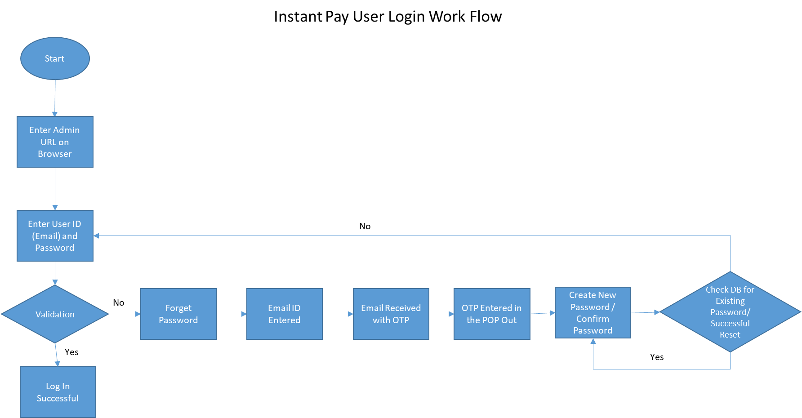

## Admin Interface Login Process Flow:

Step 1: Admin will log in to the application from a separate URL which will have private access limited to the Instant Pay Internal User only

Step 2: Admin will Enter User Name in the form of Email Address and Password which will be a standard Password input field with security validation which accepts the password in alphanumerical with special characters input.

**Marvel link :-** <https://marvelapp.com/prototype/7d1j70b/screen/73280094>

Step 3: (Exception) In the Admin does not remember the password can click on the Forget password link which will reflect the new page asking for the registered email address upon entering the user will receive an OTP at the registered email and the screen will prompt the Admin User to add received OTP and submit which once accepted will redirect to a pop up asking to create and reconfirm the new password in the Alphanumeric with Special Character pattern ensuring the previously used password is not allowed to be set again. Upon password reset a confirmation email will be triggered to the user with alert stating password has been reset.

**Marvel link :-** <https://marvelapp.com/prototype/7d1j70b/screen/73508239>

**Marvel link :-** <https://marvelapp.com/prototype/7d1j70b/screen/73725486>

**Marvel link :-** <https://marvelapp.com/prototype/7d1j70b/screen/73280583>

The option of resending the OTP will also be given in the form of a link in the Send OTP new page.

Step 4: (Successful Login) Upon Login the Admin User will land on the Application Dashboard Page by default and also be able to view sections of the application as per the roles and permissions defined to them. The following are the sections of the application which will be visible to the Admin User upon successful login;

* Dashboard
* Instant Pay User Management
* End Customers Management
* Merchant Management
* User Profile Edit Page
* Settings Section:
  + Split Payment Management
  + Payment Management
  + Subscription Management
  + Alert Template Management
  + Content Management (Consumer Website)
  + Roles and Permission Management
  + Instant Pay Users Management

Admin Dashboard:

**Marvel link :-** <https://marvelapp.com/prototype/7d1j70b/screen/73280651>

The user will have following cards on display on the dashboard page:

**Total Users:** This will display the total number of end customers who have registered on to Instant Pay Payment Services Options from the Customer Portal which will display the total number of Active users

**Total Merchants:** This card will display the total number of merchants / businesses who have subscribed for the Instant Pay payment option using the customer site. The total number of active merchant user count will be displayed in this card

**Total Number of Transactions:** This card will display the total number of transactions done using the Instant Pay platform by the end users from the merchant websites. The value will be displayed in Numeric Form and the count will be maintained for each individual transactions

**Total Transaction Amount:** This card will display the monetary value of the total number of transactions done using the Instant Pay platform by the end users from the merchant websites. The value will be displayed in Numeric Form and default currency displayed will be AUD

## Admin Interface Create Internal Users Workflow:

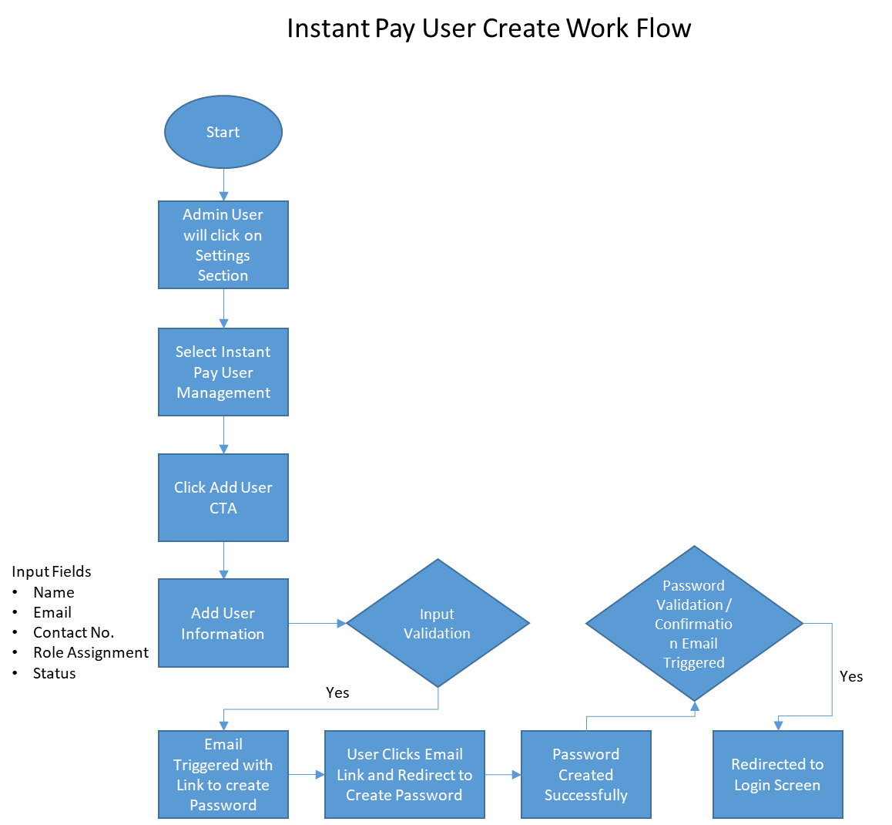

## Admin Interface Create Internal Users Process flow:

Step 1: Admin User will select the Settings Section Button of the Application

Step 2: Admin will select the Instant Pay User Management Menu

Step 3: User Management Section will have

* Search Box with (Search Anything) Which will search any content across all the grid column data
* Export to CSV CTA will prompt the user to select download destination for the CSV file. User will be able to export the entire grid data upon selection of destination
* Add User CTA (Opens New page Entry Form)
  + Name Field* – Free Text
  + Email Field* – Free Text with Email format validation
  + Contact No* – Numeric Field with format XXX-XXX-XXX
  + Role Drop Down – Drop Down Menu with the list of Roles from User Roles Section
  + Status Toggle – Active/Inactive
  + Add CTA
  + Cancel Click Icon

**Marvel link :-** <https://marvelapp.com/prototype/7d1j70b/screen/73570659>

* Grid Table with column details
  + User ID – Numeric (System Generated)
  + Name (Full Name)
  + Email – Email Address
  + Contact No. – XXX-XXX-XXX format
  + Role – Displays User Role
  + Created By – User Name
  + Status Toggle (Will be enabled for edit on role basis)
  + Action Buttons of Edit and Delete will be enabled on role basis

**Marvel link :-** <https://marvelapp.com/prototype/7d1j70b/screen/73570033>

**Marvel link :**- <https://marvelapp.com/prototype/7d1j70b/screen/73571053>

* Pagination will be available for the users
* Record Sorting Drop Down will be displayed across all Grid Pages on the Right Side bottom corner of the page with range selection of records as (10,20,50,100)

## Admin Interface Add New Role Workflow:

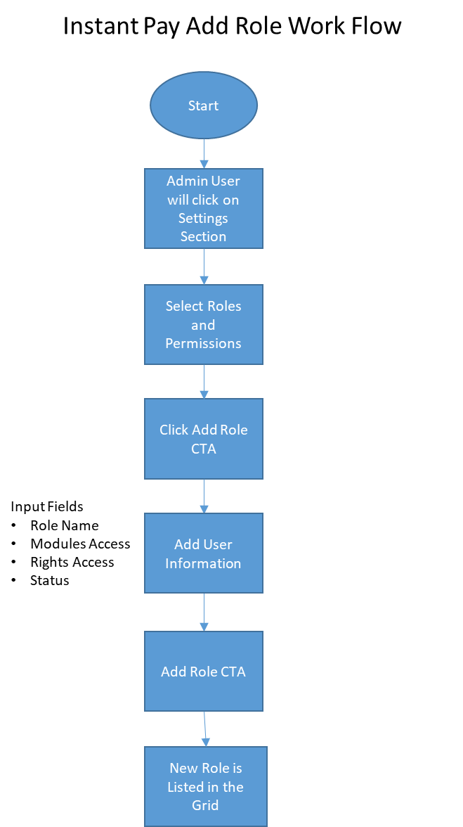

## Admin Interface Add New Role Process flow:

Note: Instant Pay User will be able to create a new role in the system provided the user has access to the Roles and Permission Module in Settings

Step 1: Instant Pay Users will click on the Settings Panel

Step 2: User will click Roles and Permission menu in the settings panel

Step 3: User Clicks Add Role CTA (Pop Opens)

Step 4: User Enters Following Fields

Roles Name* – Free Text Field

Mapped Module* – Drop Down Menu with Checkbox Multi Select Checkbox

Selection Option –

* Dashboard
* Instant Pay User Management
* End User Management
* Merchant Management
* Settings Panel

Mapped Sub Module* -- Drop Down Menu with Checkbox Multi Select Checkbox

Selection Option –

* Dashboard
  + Total Users
  + Total Merchant
  + Total Transactions
  + Total Transactions Amount (AUD)
* Instant Pay User Management
  + Add User
  + Export to CSV
  + Advance Filter Option
  + Grid Actions Option
* End User Management
  + Add User
  + Export to CSV
  + Advance Filter Option
  + Grid Actions Option
* Merchant Management
  + Add User
  + Export to CSV
  + Advance Filter Option
  + Grid Actions Option
* Settings
  + Split Payment Management
  + Payment Management
  + Subscription Management
  + Alert Template Management
  + Content Management
  + Roles and Permission Management
  + Instant Pay User Management

Status* – Toggle (Active/Inactive)

User Clicks Add CTA

**Marvel link :-** <https://marvelapp.com/prototype/7d1j70b/screen/73429388>

New Role is Added with the details entered

**Marvel link :-** <https://marvelapp.com/prototype/7d1j70b/screen/73429074>

**Marvel link :-** <https://marvelapp.com/prototype/7d1j70b/screen/73429657>

## End User Management Tab Workflow

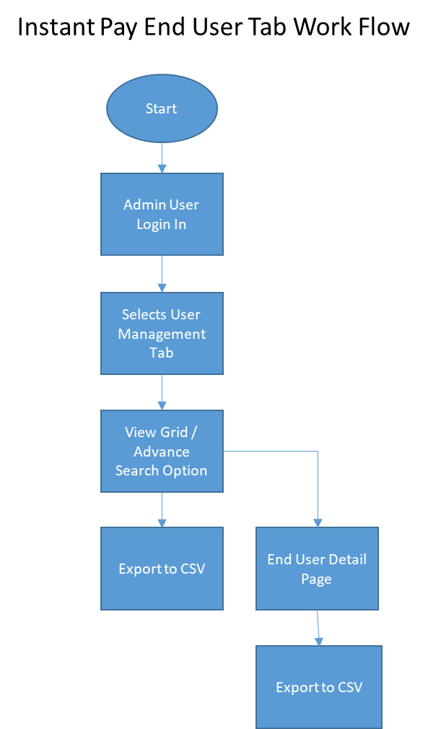

## End User Management Tab Process Flow

Users with role and permission access to User Management Module will access this

Step 1: User Login to Admin Interface

Step 2: User Clicks on User Management Tab

Step 3: User gets access to Grid view with details of the registered customer on the Instant Pay platform

Grid Columns Include: (Sorting with in the Grid available)

* User ID – Numeric (System Generated)
* Name - Alphabetic
* Email – Email Format
* Total Number of Transactions - Numeric
* Total Amount of Transactions – Amount Value
* Status Toggle
* Action (Edit/Delete)

**Marvel link :-** <https://marvelapp.com/prototype/7d1j70b/screen/73283239>

**Marvel link :-** <https://marvelapp.com/prototype/7d1j70b/screen/73287943>

**Marvel link :-** <https://marvelapp.com/prototype/7d1j70b/screen/73288670>

Step 4: Advance Search Option allows users to search Grid records with option;

* Enter User ID – Numeric Field
* Enter Name – Free Text Field
* Enter Email – Email Format Validation
* Enter Contact No. – Numeric Field (XXX-XXX-XXX Format)
* Total no. Transaction Up to – Range Slider (Min-Max) value required
* Total Amount Transacted Up to – Range Slider (Min-Max) value required
* Date Picker (From – To Calendar date range)
* Select Status – Drop Down (Active/Inactive)
* Search CTA

**Marvel link :-** <https://marvelapp.com/prototype/7d1j70b/screen/73604537>

Step 5: Export to CSV CTA allows the user to download the searched records to CSV format

Step 6: Grid Page will have Pagination and No. of records per page filter dropdown

Step 7: Instant Pay Users can access the details page of customers from the Grid record by clicking on the records

Step 8: Instant Pay user will be able to view the detailed record of the customer which includes below information;

User Detail Section:

* Name – End User Name
* Email ID – Email Address (Registered Email Address of End User)
* Contact No. – Registered Contact Number (XXX-XXX-XXX format)
* DOB – DD-MM-YYYY
* Address – Complete Billing Address of the End User
* Total Number of Transaction – Numeric Representation
* Total Amount of Transaction – Numeric Value with AUD as prefix
* List of Saved Cards – Card Type Masked representation (Visa – XXXX XX43)
* Status – Prefilled (Active/Inactive)

Grid Column Details: Default Record Sorting Available, CSV Export

* Record ID – Numeric System Generated No
* Transaction ID – Payment Transaction ID Generated from Payment Gateway
* Transaction Date – DD-MM-YYYY Format
* Payment Type – (One Time Payment represented as Ex. 1/1 | Split Payment represented as Ex. 2/6)
* Amount Transacted – Numeric with AUD Column name
* Transacted At – Merchant Name (Hyperlinked to be redirected to the merchant record in Merchant Tab)
* Payment By – Card Details (Masked Info represented “Paid By XXXX 3344”)
* Status – Success / Failure

**Marvel link :-** <https://marvelapp.com/prototype/7d1j70b/screen/73322652>

## Merchant Management Tab Workflow

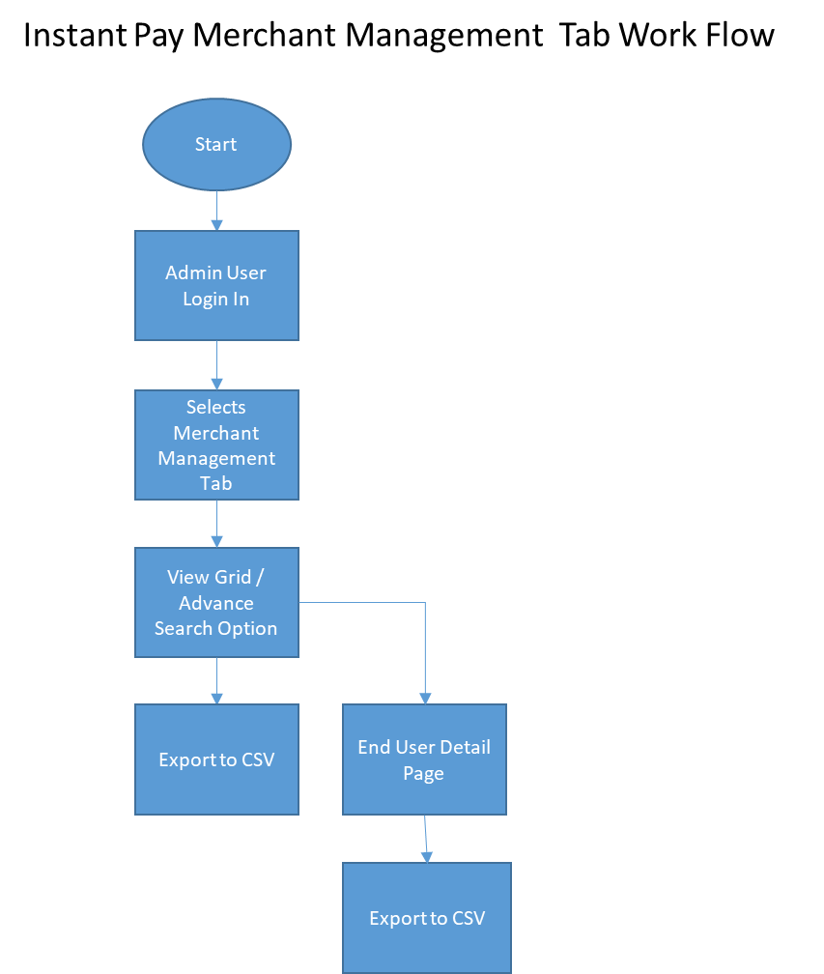

## Merchant Management Tab Process Flow

Users with role and permission access to Merchant Management Module will access this

Step 1: User Login to Admin Interface

Step 2: User Clicks on Merchant Management Tab

Step 3: User gets access to Grid view with details of the registered customer on the Instant Pay platform

Grid Columns Include;

* User ID – System Generated
* Name – Merchant / Business Name
* Email – Registered Email
* Subscription Type – Name of the Subscription Displayed
* Subscription Period – Duration of the Subscribed plan (3 Month/ 6 Months/ 1 Year)
* Valid Up to – Last Valid Date (DD-MM-YYYY)
* Action - (Approve CTA)
* Action Post Approval - (Edit/Delete)

**Marvel link :-** <https://marvelapp.com/prototype/7d1j70b/screen/73309513>

**Marvel link :**- <https://marvelapp.com/prototype/7d1j70b/screen/73311471>

**Marvel link :-** <https://marvelapp.com/prototype/7d1j70b/screen/73310775>

**Marvel link :-** <https://marvelapp.com/prototype/7d1j70b/screen/73311045>

**Marvel link :**- <https://marvelapp.com/prototype/7d1j70b/screen/73311370>

Step 4: Advance Search Option allows users to search Grid records with option;

* Enter Merchant ID – Numeric Field
* Enter Name – Free Text Field
* Enter Email – Email Format Validation
* Enter Contact No. – Numeric Field (XXX-XXX-XXX Format)
* Subscription Type – Drop Down Menu
* Subscription Period – Drop Down Menu
* Date Picker (From – To Calendar date range)
* Select Subscription Status – Drop Down (Active/Inactive)
* Select Approval Status – Drop Down (Approved/Rejected)
* Search CTA

**Marvel link :-** <https://marvelapp.com/prototype/7d1j70b/screen/73604982>

Step 5: Export to CSV CTA allows the user to download the searched records to CSV format

Step 6: Grid Page will have Pagination and No. of records per page filter dropdown

Step 7: Instant Pay Users can access the details page of customers from the Grid record by clicking on the records

Step 8: Instant Pay user will be able to view the detailed record of the Merchant which includes below information;

User Detail Section:

* Name – Merchant Name
* Email ID – Email Address (Registered Email Address of End User)
* Contact No. – Registered Contact Number (XXX-XXX-XXX format)
* Account Created On – DD-MM-YYYY
* Address – Complete Billing Address of the End User
* Subscription Name
* Subscription Duration
* Valid Up to – DD-MM-YYYY
* Status – Prefilled (Active/Inactive)

Grid Column Details: Default Record Sorting Available, Search Any Thing Input, CSV Export

* Record ID – Numeric System Generated No
* Transaction Types – One Time Payment / Split Payment
* No. Of Transaction – Numeric
* Transaction Value – Amount Numeric
* Transaction Date – DD-MM-YYYY Format

**Marvel link :-** <https://marvelapp.com/prototype/7d1j70b/screen/73346410>

## Settings Panel

**Marvel link :-** <https://marvelapp.com/prototype/7d1j70b/screen/73354170>

## Split Payment Management

Instant Pay User will be able to access the Split Payment Management panel based on role access by clicking on the Settings Panel and Split Payment Management Card to manage the Split Payment Records

Step 1: Instant Pay User will click on Split Payment Management Card

Step 2: User will be Click on Add New CTA and fill below details:

* Payment Interval – Drop Down Menu (Weekly, Monthly, 3 Months, 6 Months, 9 Months, 1 Year)
* Order Value – Drop Down (Order Value Range 100-500, 500-1000, 1000 and Above etc.)
* Add on Interest Rate – Free Text Numeric % Value
* Status – Toggle
* Add CTA

**Marvel link :-** <https://marvelapp.com/prototype/7d1j70b/screen/73598269>

The new Split Payment Record is created in the Grid Table

Step 3: Instant Pay User can view the Grid with below mentioned information in the column with sorting feature available;

* Split Payment ID – System Generated
* Payment Intervals – (Weekly, Monthly, 3 Months, 6 Months, 9 Months, 1 Year)
* Order Value Range – Numeric (Amount Range in AUD)
* Add-On Interest – Numeric % Value
* Created By – Instant Pay User Name
* Status – Toggle Active Inactive
* Action – Edit/ Delete
* Export to CSV – CTA
* Search Anything – Free Text Search Box

**Marvel link :-** <https://marvelapp.com/prototype/7d1j70b/screen/73580144>

Step 4: Edit CTA – Allows user to edit a Split Payment record from the Grid

**Marvel link :-** <https://marvelapp.com/prototype/7d1j70b/screen/73598427>

Step 5: Delete CTA – Allows the user to Delete the Split Payment Record (Soft Delete)

## Payment Management

Instant Pay User will be able to access the Payment Management panel based on role access by clicking on the Settings Panel and Payment Management Card to manage the payment records

Step 1: Instant Pay User will click on Payment Management Card

Step 2: User will be able to view the Grid of Payment Management with below column information with Search Anything Free Text Box and Export to CSV CTA (Grid will have Pagination, No. of Records Selection Dropdown)

* ID – Numeric Value (System Generated)
* Transaction ID – Numeric (Generated from Payment Gateway)
* Transaction Date – DD-MM-YYYY
* Processed Through – Payment Processor Provider **Card Access**
* Transaction Amount – Numeric with AUD Prefix
* Transacted By – End User Name
* Transaction Interval – One Click / Split Payment
* Transacted Via – Masked Card Number (XXX-XX44)
* Status – Success, Failed, Refunded
* ~~Action – Refund CTA (Will only be enabled for authorized user and Success Status)~~

**Marvel link :-** <https://marvelapp.com/prototype/7d1j70b/screen/73355643>

**Marvel link :**- <https://marvelapp.com/prototype/7d1j70b/screen/73356755>

Step 3: Refund Process can be initiated by Authorized users for Success transactions by clicking the Refund CTA in the Grid in Action column

* ~~Apply Refund will ask user to confirm~~
* **~~Upon Confirmation the refund process will be initiated against the transaction number (TBD)~~**
* ~~Email trigger for the refund will be sent to the customer~~
* ~~Refund Status will display information mouse hover icon to indicate the refund amount, date and initiated by field~~

**Marvel link :-** <https://marvelapp.com/prototype/7d1j70b/screen/73357742>

## Subscription Management

Instant Pay users who have permission can access the Subscription Management Card in the settings to manage the Subscription of the Merchants

Step 1: Click Subscription Management Card

Step 2: Add New CTA – Allows user to Add New Subscription Plan with below details

* Subscription Name – Numeric Field
* Checkout Options – Drop Down (Multi Select – One Click, Split Payment, Both)
* Subscription Fee – Free Text Value (Monthly/ Yearly)
* Minimum Application Duration – (Months/Years)
* Status - Toggle
* Subscription Details – Free Text (Limited to 300 Characters)
* Add CTA

**Marvel link :-** <https://marvelapp.com/prototype/7d1j70b/screen/73393753>

Once the record is created user can see the subscription in the Grid

Steps 3: Subscription View Grid Table with below details having default sorting, Search Anything Text Box, Export to CSV option

* ID – System Generated
* Subscription Name – Alphabetical
* Checkout Option – Split, One Click, Both
* Subscription Fee – Value with prefix AUD
* Minimum Duration – Month/ Year
* Created by – User Name
* Status – Toggle
* Action – Edit / Delete (Soft Delete)

**Marvel link :-** <https://marvelapp.com/prototype/7d1j70b/screen/73391664>

**Marvel link :**- <https://marvelapp.com/prototype/7d1j70b/screen/73393070>

**Marvel link :**- <https://marvelapp.com/prototype/7d1j70b/screen/73392866>

**Marvel link :**- <https://marvelapp.com/prototype/7d1j70b/screen/73394418>

**Marvel link :**- <https://marvelapp.com/prototype/7d1j70b/screen/73392758>

## Alert Template Management

Instant Pay Users can manage the Notification and Email Alerts Templates for the application from here as per user permission given

Step 1: Instant Pay User Click Alert Template Management Card in Settings

Step 2: Add New CTA – User will be able to create new alert template with below field in new page

* Alert Type – Drop Down Menu
* Communication Mode – Email / Notification (End User, Merchant, Admin Users)
* Add Content CTA – New page for template management
* Add content – Email / SMS Tab
* Select Template Edit – End User, Merchant, Admin
* Compose Template – Text Editor
* Add Template – CTA

**Marvel link :-** <https://marvelapp.com/prototype/7d1j70b/screen/73399121>

**Marvel link :-** <https://marvelapp.com/prototype/7d1j70b/screen/73601645>

Step 3: Alert Template is added to Grid with display of columns as mentioned below with Export to CSV, Search Anything Free Text Box

* ID – System Generated
* Alert Type – Name of the Alert
* Communication Mode – Icon (Bell, Email)
* Created By – Name of the user
* Status – Toggle
* Action – Edit / Delete

**Marvel link :-** <https://marvelapp.com/prototype/7d1j70b/screen/73398884>

**Marvel link :-** <https://marvelapp.com/prototype/7d1j70b/screen/73400102>

## Content Management

Instant Pay User will be able to manage the content from this section based on access permissions

Step 1: Instant Pay User Clicks Content Management Card

Step 2: Application contents static pages such as;

* Social Media Links
* App Version
* Contact Us for Query
* Terms & Conditions
* Privacy Policy
* FAQ Related to API

Administrator can add, update and delete contents of these pages.

**Marvel link :-** <https://marvelapp.com/prototype/7d1j70b/screen/73718138>

**Marvel link :-** <https://marvelapp.com/prototype/7d1j70b/screen/73718526>

**Marvel link :-** <https://marvelapp.com/prototype/7d1j70b/screen/73719024>

**Marvel link :-** <https://marvelapp.com/prototype/7d1j70b/screen/73722548>

**Marvel link :-** <https://marvelapp.com/prototype/7d1j70b/screen/73786111>

**Marvel link :-** <https://marvelapp.com/prototype/7d1j70b/screen/73787062>

**Marvel link :-** <https://marvelapp.com/prototype/7d1j70b/screen/73787801>

**Marvel link :-** <https://marvelapp.com/prototype/7d1j70b/screen/73788831>

## Notification Bell Icon

The Notification Icon will show count of system notifications received for the user

Step1: User Clicks Bell Icon CTA

Step 2: User clicks on the notification from the new page to view the notification which will then be marked as read and reduce the total count of the Bell Icon from that of the previous count

**Marvel link :-** <https://marvelapp.com/prototype/7d1j70b/screen/74023568>

## User Profile

Instant Pay User will able to manage their user profile by clicking on the profile icon to view and edit their profiles

Step 1: Instant Pay user login to the interface

Step 2: User clicks on the Profile Icon on the Interface

**Marvel link :-** <https://marvelapp.com/prototype/7d1j70b/screen/73282795>

Step 3: User clicks on edit profile icon

Step 4: User is able to Edit Profile with below fields;

Profile Image – Add / Remove Profile Image

Contact No. – XXX-XXX-XXX

**Marvel link :-** <https://marvelapp.com/prototype/7d1j70b/screen/73509190>

**Marvel link :-** <https://marvelapp.com/prototype/7d1j70b/screen/73509394>

**Marvel link :-** <https://marvelapp.com/prototype/7d1j70b/screen/73666377>

## Logout

Instant Pay user can log out of the application after logging in

Step 1: Instant Pay user click on the Profile Icon

Step 2: User clicks on the Logout CTA (User will be redirected to the log in page)

**Marvel link :-** <https://marvelapp.com/prototype/7d1j70b/screen/73282795>

# End Customer Front-end: User Interface Functionality

This section will cover the functionality of the end user who will be registering themselves on to the Instant Pay platform by entering their Credit Card information and billing details to enable them to utilize the Instant Pay checkout services at the different Merchant portals who have partnered with Instant Pay checkout services.

## End Customer Registration Workflow

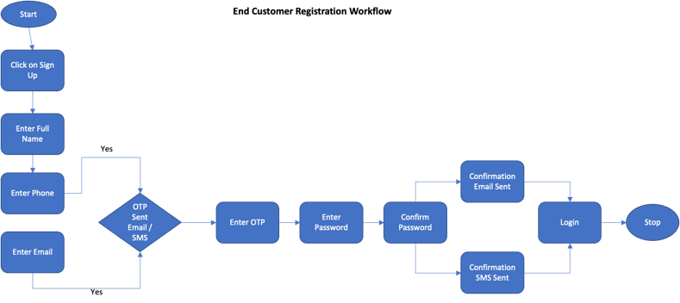

## End Customer Register Process Flow

Step 1: The end user (Customer) shall visit the URL of the Marketing Portal of Instant Pay to get themselves signed in / registered

**Marvel link :-** <https://marvelapp.com/prototype/94a8271/screen/73610261>

Step 2: The end customer shall be redirected to the Sign Up screen with the following fields to enter

* Full Name* - Free Text Box
* Mandate Fields*
* Mobile Number - +XX-XXX-XXX-XXX (Format) Should have OTP Generate Trigger CTA with validity of 60 Sec and post that Resend OTP CTA should appear
* Mobile OTP Input Box – Numeric Field (Should have Confirm OTP CTA)
* Email Field* - Should have OTP Generate Trigger CTA with validity of 60 Sec and post that Resend OTP CTA should appear
* Email OPT Input Box – Numeric Field (Should have Confirm OTP CTA)
* Password* - Alphanumeric with Number and Special Character
* Confirm Password* - Should match password - Alphanumeric with Number and Special Character
* Sign Up CTA
* Confirmation Email Triggered with the user ID and welcome message along with the new registration email template to the user’s registered email address
* Confirmation SMS Triggered with the user ID along with SMS welcome template on registered mobile number

Marvel link :- <https://marvelapp.com/prototype/7dga270/screen/73912904>

Marvel link :- <https://marvelapp.com/prototype/7dga270/screen/73912961>

Marvel link :- <https://marvelapp.com/prototype/7dga270/screen/73913000>

Marvel link :- <https://marvelapp.com/prototype/7dga270/screen/73913046>

## End Customer Login and Forget Password Workflow



## Login

Step 1: User visit the Instant Pay marketing site and click Sign In CTA

Step 2: User enters Email / Phone Number with Password

**Marvel link :-** <https://marvelapp.com/prototype/7d1j70b/screen/73280094>

Step3: Optional: The user will see a checkbox option of keep me signed in (This will allow the user to be signed in for faster checkouts from the merchant portals this initially will be valid for 24 hours before it prompts for login again)

Step 4: User clicks Login CTA -

## Forget Password:

Step 5: User enters Phone / Email and click on Forget Password link option

Step 6: User is prompted for entering email address, when entered an OTP is sent out to the email inbox

**Marvel link :-** <https://marvelapp.com/prototype/7d1j70b/screen/73508239>

Step 7: User validated the OTP on the input field which activates the New Password and Confirm password input fields

**Marvel link :-** <https://marvelapp.com/prototype/7d1j70b/screen/73725486>

Step 8: The user will enter the new and confirm password and click Submit CTA

**Marvel link :-** <https://marvelapp.com/prototype/7d1j70b/screen/73280583>

Step 9: User Logs in on to landing page with Default Dashboard

## User Dashboard

User once logged in will be able to view data on the Customer Dashboard page which will be as per the below details:

**Marvel link :-** <https://marvelapp.com/prototype/7dga270/screen/73635184>

## Data Display Cards:

* Total Successful Transactions
* Total Failed Transactions
* Pending Refunds
* Total Amount Spent using Instant Pay

## Data Grid:

User will be able to see Grid Table with Pagination and Records per page filter with default column sorting

* Transaction ID
* Transaction Date
* Split Instalment
* Total Amount in AU$
* Transacted against (Merchant)
* Payment Type (CC/DC)
* Payment Detail – XXXX-XX55 (Format)
* Status

## Transaction Detail Information:

Step 1: User Click on Any record from the Data Grid on the Dashboard

Step 2: User will be redirected to the Transaction Detail Page with below Information;

User will be able to see Grid Table with Pagination and Records per page filter with default column sorting

**Marvel link :-** <https://marvelapp.com/prototype/7dga270/screen/73643054>

* Transaction ID
* Billed Amount
* Card Type (Ending with XXXX-XX44)
* Status (Success/Failure)
* Merchant Name
* Date and Time Stamp

## Payment Method Setup

Here the user will be required to fill in the profile and payment information with the card details and billing information

Step 1: First Time Registered Users will be prompt on the notification to complete the payment information details

**Marvel link :-** <https://marvelapp.com/prototype/7dga270/screen/73836636>

Step 2: User navigate the payment page clicks the tab

Step 3: User will be asked to fill in information in the Profile Tab

First Name* – Free text field

Last Name* – Free text field

DOB* – Date Picker (MMDDYYYY)

Default contact Email Address*: Email Input field

Next CTA

Step 4: User will Enter the Credit Card Details in the Payment Tab

* Name on the Card
* Card Number* - Numeric 16 Digit (After Entering the first 8 digits the Card Icon changes to the relevant card type (Visa/Master)
* Expiry Date*
* Zip/Postal Code
* Add CTA

**Marvel link :-** <https://marvelapp.com/prototype/7dga270/screen/73667614>

**Marvel link :**- <https://marvelapp.com/prototype/7dga270/screen/73667008>

*User can choose to Add Multiple Cards*

*User will have to choose at least One Card as a default for using it with Instant Pay transactions*

~~Step 5: User will add Default Billing Address in the Address Tab~~

* ~~Address Line 1*~~
* ~~Address Line 2*~~
* ~~City*~~
* ~~State*~~
* ~~Country*~~
* ~~Zip*~~
* ~~Add Address CTA~~

## ~~Transaction Page~~

~~User will be able to view all the transactions that are been processed using the Instant Pay payment process on this tab with the detailed status of the transactions against each Orders~~

~~Step 1: User will click on the Transaction Page Tab to navigate to the page~~

~~Step2: User will be able to see Grid Table with Pagination and Records per page filter with default column sorting and Export To CSV CTA~~

**~~Marvel link :-~~**[~~https://marvelapp.com/prototype/7dga270/screen/73646148~~](https://marvelapp.com/prototype/7dga270/screen/73646148)

* ~~Record ID: Shows the records numbers (System Generated)~~
* ~~Order ID: Merchant Order ID to be shown here for the Purchase made (In case Multiple Transaction against one order ID the record can be expanded to view multiple transaction done against the same Order ID in case user has selected Split Payment option against the order)~~
* ~~Transaction ID: Displays the actual Transaction ID from the Payment Gateway which is generated~~
* ~~Transaction Date~~
* ~~No. Of Instalments: (Represented in form of 1/3, 2/3, 3/3, 1/1 etc.)~~
* ~~Total Amount spend on the Transaction: In AU$~~
* ~~Merchant Name: Represented where the transaction was processed~~
* ~~Payment Type: Represent Type of Card used (Credit/Debit)~~
* ~~Payment Detail: (Card Ending XXXX-XX30)~~
* ~~Status: Success/Failure~~

~~User will also have a advance search filter option reflected on the edge of the Grid which will expand and reflect selected search by options:~~

* ~~Search By: Date Picker Range~~
* ~~Payment Type: Drop Down (One Time Payment / Split Payment)~~
* ~~Merchant Name: Drop Down~~
* ~~Status Type: Drop Down (Success /Failure)~~
* ~~Transaction Amount: Min Max range bar (AU$)~~

## ~~Transaction Detail Page~~

~~User will be able to access the detail page of the Transaction Detail Page which will give detailed view of the transactions~~

~~User will have detail view of the~~

* ~~Date~~
* ~~Merchant Name~~
* ~~Order ID: (Merchant Order Number in View Mode)~~
* ~~Order Amount: (Total Order Value in AU$)~~
* ~~Transaction ID: (View Mode) – In case of Split Payment Grid will appear with each transaction for the instalments in a single row against the Order ID~~
* ~~Payment Time Stamp:~~
* ~~Payment Type: View Mode~~
* ~~Merchant Name~~

**Marvel link :-** <https://marvelapp.com/prototype/7dga270/screen/73643054>

## Notification

Here the user will be able to see all the Notification represented in the form of a Bell Icon on the right hand top part of the application interface screen. The Bell icon will have a counter representing the number of alerts for the notification that the user’s attention is required for.

User Navigation:

Step 1: User will Login to the User Interface

Step 2: User will navigate to the notification page by clicking on the Bell Icon on the right side top of the screen

Step 3: User will be redirected to a Notification Detail Grid where the user will see the number of records as shown in the counter representation the number of Notification on the Bell Icon in the form of Numeric value.

**Marvel link :-** <https://marvelapp.com/prototype/7dga270/screen/73647382>

Step 4: The counter on the Notification Bell Icon will be removed when a user click on the icon to navigate to the detail page of the notification unless there is new notification that has been triggered

Step 4: User will see the Grid with column information as below;

* Notification ID: System Generated Numeric Value
* Title: This will represent the Title of the Notification as per the defined system notification from the Admin Interface
* Notification Info: This will represent the Detailed Message Template which is set against the Notification Title in the Admin Interface

## My Profile

Here the User will the user will be able to maintain the profile information and the user can Log Out of the Application

Step 1: User will be able navigate to My Profile from the User Interface Landing Page by Clicking on the User Icon on the right top of the application interface

Step 2: User views the User Image and Name along with Edit Icon and Logout CTA

**Marvel link :-** <https://marvelapp.com/prototype/7d1j70b/screen/73282795>

Step 3: User selects Edit Icon to enter Profile Edit Page

Step 4: User here will be able to:

* Upload Image – (jpeg ,png) Up to maximum 2 Mb size
* Name Edit: Free Text Field
* Mobile Number: XXX-XXX-XXX format
* Email ID: Email Validation field
* Change Password – Hyperlink to redirect to password change page
  + User Enters Current Password (Password Field)
  + User Enters New Password (Password Field) Alphanumeric with Numeric and Special Character
  + User Enters Confirm Password (Password Field) Alphanumeric with Numeric and Special Character
  + Upon successful change an Email is triggered to the User on the registered email address and SMS triggered notifying password change
* User Clicks on Save CTA to Save changes

**Marvel link :-** <https://marvelapp.com/prototype/7d1j70b/screen/73509190>

**Marvel link :**- <https://marvelapp.com/prototype/7d1j70b/screen/73509394>

**Marvel link :**- <https://marvelapp.com/prototype/7d1j70b/screen/73666377>

## Logout

Step 1: User Click on the Profile Image on the top right of the screen to view the Logout CTA

Step2: User clicks on Logout CTA to successfully logout

**Marvel link :-** <https://marvelapp.com/prototype/7d1j70b/screen/73282795>

## Footer Links

Here user will be able to see all the links as per the defined footer links configured

Links

* Social Media Links
* App Version
* Terms and Conditions
* ~~About Us~~
* Contact Us
* Privacy Policy

**Marvel link :-** <https://marvelapp.com/prototype/94a8271/screen/73610261>

# Merchant Front-end: Marketing Landing Page

This will be a URL for the Merchant similar to that of the end Users who would like to avail the services and sign up for the Instant Pay Quick Payment APIs using the offered subscriptions and also the portal where the Instant Pay installation guidelines are given to the Merchant to easily implemented the Instant Pay checkout page with in their existing business portal such as an E-commerce platform.

**Marvel link :-** <https://marvelapp.com/prototype/94a8271/screen/73610261>

## Merchant Registration Workflow

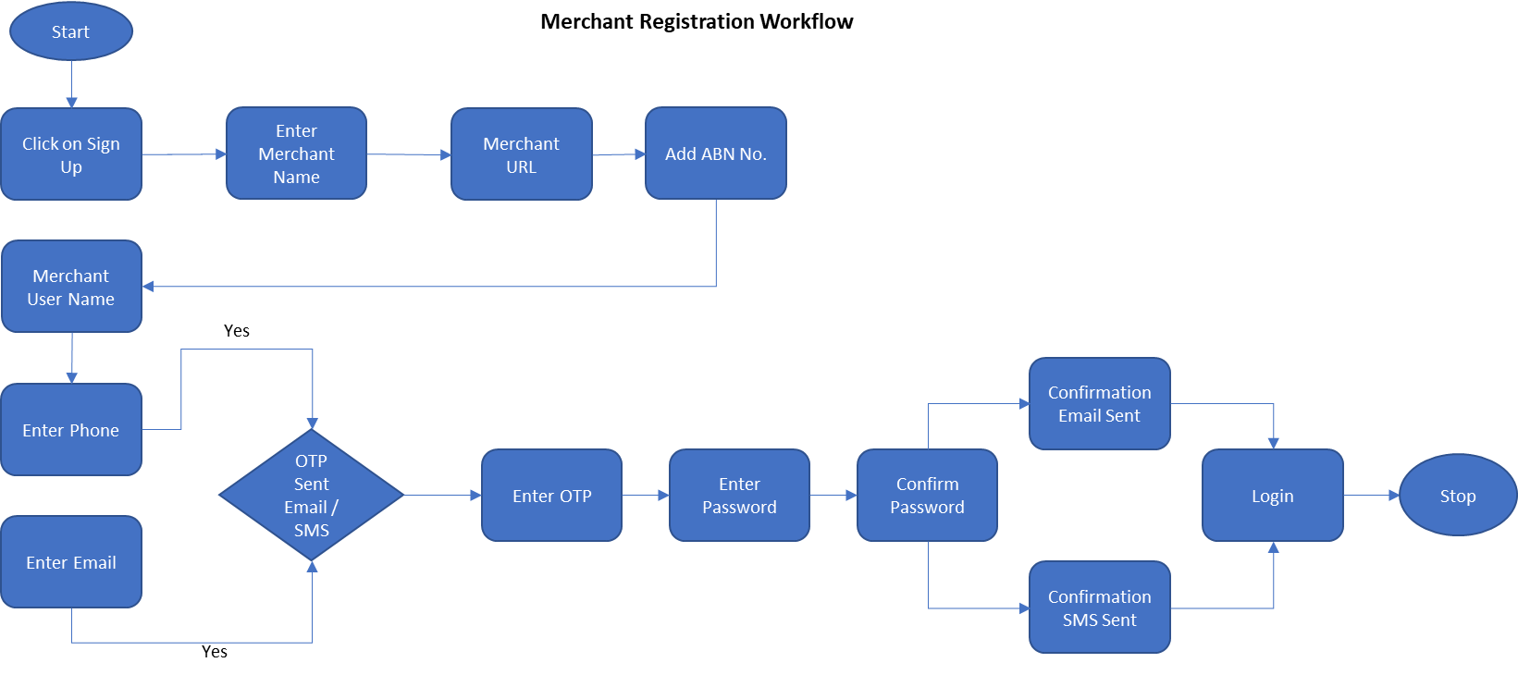

## Register / Sign In

Step 1: The Merchant shall visit the URL of the Marketing Portal of Instant Pay to get themselves signed in / registered by choosing the Merchant Sign Up option

**Marvel link :-** <https://marvelapp.com/prototype/94a8271/screen/73611291>

**Marvel link :-** <https://marvelapp.com/prototype/94a8271/screen/73612191>

Step 2: The end Merchant will be redirected to the Sign Up screen with the following fields to enter

**Marvel link :-** <https://marvelapp.com/prototype/94a8271/screen/73612341>

* Merchant Name* - Free Text Field
* Merchant URL:
* Full Name* - Free Text Box
* Mandate Fields*
* Mobile Number - +XX-XXX-XXX-XXX (Format) Should have OTP Generate Trigger CTA with validity of 60 Sec and post that Resend OTP CTA should appear

**Marvel link :-** <https://marvelapp.com/prototype/94a8271/screen/73612528>

**Marvel link :**- <https://marvelapp.com/prototype/94a8271/screen/73612593>

**Marvel link :**- <https://marvelapp.com/prototype/94a8271/screen/73612707>

* Mobile OTP Input Box – Numeric Field (Should have Confirm OTP CTA)
* Email Field* - Should have OTP Generate Trigger CTA with validity of 60 Sec and post that Resend OTP CTA should appear
* Email OPT Input Box – Numeric Field (Should have Confirm OTP CTA)
* Password* - Alphanumeric with Number and Special Character
* Confirm Password* - Should match password - Alphanumeric with Number and Special Character
* Country, State, City, BusinessType, ABN no need to add while registration.
* Sign Up CTA
* Confirmation Email Triggered with the user ID and welcome message along with the new registration email template to the user’s registered email address
* Confirmation SMS Triggered with the user ID along with SMS welcome template on registered mobile number

## API Information

This section of the Marketing Landing Page will provide the different API documentation of to the Merchants for the implementation of the Instant Pay One Click payment services on their platforms

**Marvel link :-** <https://marvelapp.com/prototype/94a8271/screen/74032778>

## Product Information Page

Here the Merchant will be able to visit and read the product information and features and possibilities of utilization of the Instant Pay One Click Payment service. The content on this page will be manage through the Instant Pay Admin Interface and can control the control to be displayed on this page. The page will be open to non-subscribed users as well.

**Marvel link :-** <https://marvelapp.com/prototype/94a8271/screen/73610261>

## Contact Us Page

The visitor of the Merchant Marketing page will find the contact information and support email for the Instant Pay customer support team on this page along with the information on the registered office and other information. This page will be added with content from the Admin Interface content management section.

**Marvel link :-** <https://marvelapp.com/prototype/94a8271/screen/74031707>

## Footer Links

This section on the Merchant Marketing Portal will be controlled from the Admin Interface for the footer pages and links for the site visitors

# Merchant Back-end: Merchant Web Interface

This interface will be provided to the Merchant once they have created an account on the Instant Pay marketing portal. The purpose of this interface the is for the merchant can view their profile information and the have information towards

## Merchant Login and Forget Password Workflow



## Login

Step 1: Merchant visit the Instant Pay marketing site and click Sign In CTA

**Marvel link :-** <https://marvelapp.com/prototype/94a8271/screen/73610261>

Step 2: Merchant enters Email / Phone Number with Password

**Marvel link :-** <https://marvelapp.com/prototype/94a8271/screen/73611291>

Step 4: User clicks Login CTA

## Forget Password:

Step 5: Merchant enters Phone / Email and click on Forget Password link option

Step 6: Merchant is prompted for entering email address, when entered an OTP is sent out to the email inbox

**Marvel link :-** <https://marvelapp.com/prototype/94a8271/screen/73611608>

Step 7: Merchant validated the OTP on the input field which activates the New Password and Confirm password input fields

**Marvel link :-** <https://marvelapp.com/prototype/94a8271/screen/73870270>

Step 8: The user will enter the new and confirm password and click Submit CTA

**Marvel link :-** <https://marvelapp.com/prototype/94a8271/screen/73612144>

Step 9: User Logs in on to landing page with Default Dashboard

## My Profile

Here the Merchant will be able to maintain the profile information and the user can Log Out of the Application

Step 1: Merchant will be able navigate to My Profile from the User Interface Landing Page by Clicking on the User Icon on the right top of the application interface

Step 2: Merchant views the User Image and Name along with Edit Icon and Logout CTA

**Marvel link :-** <https://marvelapp.com/prototype/94a8271/screen/73640596>

Step 3: Merchant selects Edit Icon to enter Profile Edit Page

**Marvel link :-** <https://marvelapp.com/prototype/94a8271/screen/73632101>

**Marvel link :-** <https://marvelapp.com/prototype/94a8271/screen/73632179>

**Marvel link :-** <https://marvelapp.com/prototype/94a8271/screen/73612144>

Step 4: Merchant here will be able to:

## Merchant Dashboard

Merchant user will be landed on the Merchant interface dashboard after login where the dashboard will reflect information cards and other critical dashboard information

Merchant will view the recent transaction list in the form of a Grid with below columns:

**Marvel link :-** <https://marvelapp.com/prototype/94a8271/screen/73613824>

* Date: DD-MM-YYYY
* Order ID (Billing Order ID)
* Transaction ID (Auto Generated Code from Payment Gateway)
* Transaction Value: AU$
* Email ID of the Customer: Email Field
* Contact Number of Customer: XXX-XXX-XXX
* Payment Details: CC – XXXX-XX33 Format
* Status – (Success/Failed)
* Action – Initiate Refund

Merchant will be able to use the Advance search option in the Grid with options to search:

* By Email ID
* By Contact Number
* Order ID:
* Date:
* Order Amount: Range Bar (Min/Max AU$)

Display Cards:

* Daily Sales Using Instant Pay
* Current Month Sales
* Number of Users Count
* Total Orders Using Instant Pay

## Transaction History

Here the merchant will be able to view the listing of Transactions for the customers who have transacted at the Merchant portal using the Instant Pay Payment checkout process.

The listing Grid with sorting, Export to CSV and Advance Search and Pagination and Records per page feature; will include below columns

**Marvel link :-** <https://marvelapp.com/prototype/94a8271/screen/73643379>

* Date: DD-MM-YYYY
* Order ID (Billing Order ID)
* Transaction ID (Auto Generated Code from Payment Gateway)
* Transaction Value: AU$
* Email ID of the Customer: Email Field
* Contact Number of Customer: XXX-XXX-XXX
* Payment Details: CC – XXXX-XX33 Format
* Status – (Success/Failed)
* Action – Initiate Refund

Merchant will be able to use the Advance search option in the Grid with options to search:

* By Email ID
* By Contact Number
* Order ID:
* Date:
* Order Amount: Range Bar (Min/Max AU$)

Transaction Detail Page

Merchant can click on the Grid record to enter a new page representing the Transaction Detail Page

The Page will have below information in view mode

* Date: DD-MM-YYYY
* Customer Name:
* Customer Contact No:
* Customer Email:
* Order ID:
* Transaction ID:
* Payment By: Credit Card
* Payment Type: XXXX-XX33
* Date and Time:
* Payment Status: Success/ Failure
* Refund CTA

## Merchant Interface Create Internal Users Process flow:

Step 1: Merchant User will select the Settings Section Button of the Application

Step 2: Merchant will select the Instant Pay User Management Menu

**Marvel link :-** <https://marvelapp.com/prototype/94a8271/screen/74021494>

Step 3: User Management Section will have

* Search Box with (Search Anything) Which will search any content across all the grid column data
* Export to CSV CTA will prompt the user to select download destination for the CSV file. User will be able to export the entire grid data upon selection of destination
* Add User CTA (Opens New page Entry Form)
  + Name Field* – Free Text
  + Email Field* – Free Text with Email format validation
  + Contact No* – Numeric Field with format XXX-XXX-XXX
  + Role Drop Down – Drop Down Menu with the list of Roles from User Roles Section
  + Status Toggle – Active/Inactive
  + Add CTA
  + Cancel Click Icon

**Marvel link :-** <https://marvelapp.com/prototype/94a8271/screen/74022643>

* Grid Table with column details
  + User ID – Numeric (System Generated)
  + Name (Full Name)
  + Email – Email Address
  + Contact No. – XXX-XXX-XXX format
  + Role – Displays User Role
  + Created By – User Name
  + Status Toggle (Will be enabled for edit on role basis)
  + Action Buttons of Edit and Delete will be enabled on role basis

**Marvel link :-** <https://marvelapp.com/prototype/94a8271/screen/74022227>

**Marvel link :**- <https://marvelapp.com/prototype/94a8271/screen/74022746>

* Pagination will be available for the users
* Record Sorting Drop Down will be displayed across all Grid Pages on the Right Side bottom corner of the page with range selection of records as (10,20,50,100)

## Merchant Interface Add New Role Process flow:

Note: Instant Pay User will be able to create a new role in the system provided the user has access to the Roles and Permission Module in Settings

Step 1: Instant Pay Users will click on the Settings Panel

Step 2: User will click Roles and Permission menu in the settings panel

**Marvel link :-** <https://marvelapp.com/prototype/94a8271/screen/74021494>

Step 3: User Clicks Add Role CTA (Pop Opens)

Step 4: User Enters Following Fields

Roles Name* – Free Text Field

Mapped Module* – Drop Down Menu with Checkbox Multi Select Checkbox

Selection Option –

* Dashboard
* Transaction History
* Sales Report
* Subscription Management
* Settings Panel

**Marvel link :-** <https://marvelapp.com/prototype/94a8271/screen/74021986>

**Marvel link :**- <https://marvelapp.com/prototype/94a8271/screen/74021719>

**Marvel link :**- <https://marvelapp.com/prototype/94a8271/screen/74022083>

## Sales Reports

Here the Merchant will be able to view the Sales Report of the Transactions

Step 1: Merchant will click on the Reports Tab

Step 2: Merchant will Select the Date Range from the Date Picker CTA and Click Search CTA

Step 3: Merchant will view the search result in Grid Form with the records as per the search results

Step 4: Merchant user will view the Grid with below columns:

* Date: DD-MM-YYYY
* Order ID (Billing Order ID)
* Transaction ID (Auto Generated Code from Payment Gateway)
* Transaction Value: AU$
* Email ID of the Customer: Email Field
* Contact Number of Customer: XXX-XXX-XXX
* Payment Details: CC – XXXX-XX33 Format
* Status – (Success/Failed)

**Marvel link :-** <https://marvelapp.com/prototype/94a8271/screen/73643536>

Step 5: User will be able to export the report to CSV format

## Merchant Subscription Plan Workflow



## Subscription

Merchant will be able to view and manage the subscription from this page and also upgrade and cancel the subscription

Step 1: Merchant will be able to view the Subscription Tab in the Merchant Interface after Login

Step 2: Merchant will click on the Subscription Tab to view;

**Marvel link :-** <https://marvelapp.com/prototype/94a8271/screen/73643631>

Subscription Name: (One Click / Split Payment / One Click and Split Payment Both)

Subscription Information: (This field will be providing a brief information on Subscription type and facilities available towards th e subscription

Subscription Validly: Merchant will view the validity period against each subscription

Step 3: Merchant user will choose the ideal plan for the subscription by choosing the Select Plan CTA which will redirect the Merchant to the next page where payment will be processed

Step 4: Merchant will be will able to complete the payment by entering the Card Information and Billing details and click on Pay CTA to complete the payment.

**Marvel link :-** <https://marvelapp.com/prototype/94a8271/screen/73676657>

Step 5: Merchant will receive the confirmation email via email on the registered email and a notification on the Merchant Interface for the subscription and also the confirmation email will content information on the APIs and its keys.

Step 6: The Merchant user will have access to the view form of the subscription where they can view the Subscription Name, Type, Validity and a CTA for Change and Cancel as explained below;

**Marvel link :-** <https://marvelapp.com/prototype/94a8271/screen/73676138>

* Merchant can Change to a different Subscription plan by clicking on the Change CTA which will redirect to the Choose Subscription Plan as mentioned in Step 2 above and run by the same process.

**Marvel link :-** <https://marvelapp.com/prototype/94a8271/screen/73999122>

* Merchant can choose to Cancel the Subscription at given time by clicking on Cancel subscription and this will ask for a confirmation using a Pop-Out with a Confirm or Cancel CTA for the user to choose from

**Marvel link :-** <https://marvelapp.com/prototype/94a8271/screen/73988879>

* For both change in plan will trigger email to Merchant user similar to that of Step 5 and for the cancellation the Merchant will receive the confirmation email and simultaneously the system will disable the APIs and the Keys on the merchant websites to avoid future checkouts for Customers using Instant Pay for that Merchant

## Notification

Here the user will be able to see all the Notification represented in the form of a Bell Icon on the right hand top part of the application interface screen. The Bell icon will have a counter representing the number of alerts for the notification that the user’s attention is required for.

User Navigation:

Step 1: User will Login to the User Interface

Step 2: User will navigate to the notification page by clicking on the Bell Icon on the right side top of the screen

Step 3: User will be redirected to a Notification Detail Grid where the user will see the number of records as shown in the counter representation the number of Notification on the Bell Icon in the form of Numeric value.

Step 4: The counter on the Notification Bell Icon will be removed when a user click on the icon to navigate to the detail page of the notification unless there is new notification that has been triggered

Step 4: User will see the Grid with column information as below;

* Notification ID: System Generated Numeric Value
* Title: This will represent the Title of the Notification as per the defined system notification from the Admin Interface
* Notification Info: This will represent the Detailed Message Template which is set against the Notification Title in the Admin Interface

**Marvel link :-** <https://marvelapp.com/prototype/94a8271/screen/73665526>

## Footer Links

Here user will be able to see all the links as per the defined footer links configured

Links

* Social Media Links
* App Version
* Terms and Conditions
* About Us
* Privacy Policy

**Marvel link :-** <https://marvelapp.com/prototype/94a8271/screen/73610261>

# End Customer Check-Out process from Merchant Online Portals

This module will feature the user of Instant Pay by the end users from the partner Merchant’s online portal where the end user will be able to utilize the Instant Pay checkout option for making payments towards their online purchase on the online portal.

Step 1: End User (Online Customer for the Merchant) will visit the Merchant Portal for purchasing any items

Step 2: User will select Instant Pay One Click Payment or Instant Pay Split Payment Option as per the availability on the Merchant Website and as per the requirement of the User on the Check-Out page

**Marvel link :-** <https://marvelapp.com/prototype/94a8271/screen/73993324>

**Marvel link :-** <https://marvelapp.com/prototype/94a8271/screen/73993530>

Step 3: User will only see the option on the checkout page which the Merchant has Subscribed for (Example: One Click Checkout, Split Payment Checkout or Both)

Step 4: User will be also able to Initiate Cancellation or Refund for a particular Order placed from from the Merchant Portal which is solely possible in case the merchant portal have allowed this option to the user

Step 5: For Cancelled and Refunds of orders processed using Instant Pay payment system will be reverted once this is triggered from the Merchant Portal

## Instant Pay One Click Payment Option Workflow By End Customer

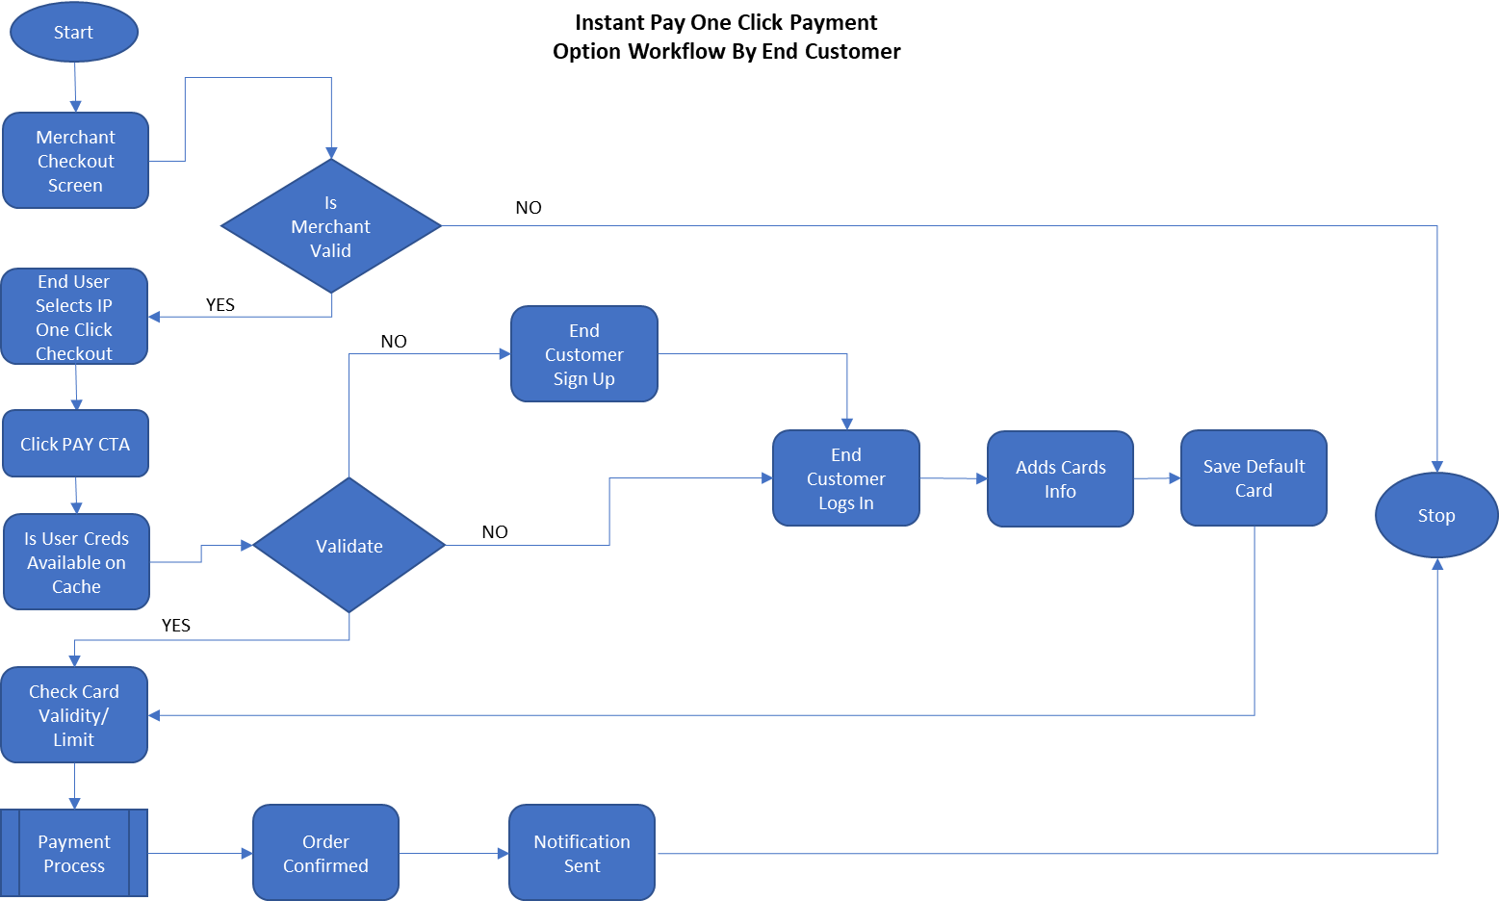

## Instant Pay One Click Payment Option Process Flow By End Customer

Step 1: Once user have selected the Instant Pay One Click Payment Option using Merchant Checkout page after adding items to the cart

Step 2: The system will check if Merchant is Valid and the User is (Exist and Signed In / Need to Sign In / Need to Register and Sign In)

Already signed in to the Instant Pay payment portal and have chosen the option of “Keep Me Signed In for faster checkout” if this is validated, the user will immediately view the Order confirmation page after clicking Confirm Payment CTA

**Marvel link :-** <https://marvelapp.com/prototype/94a8271/screen/74000643>

**Marvel link :-** <https://marvelapp.com/prototype/94a8271/screen/74000750>

**Marvel link :-** <https://marvelapp.com/prototype/94a8271/screen/74001978>

OR

The User is redirected to the Instant Pay Marketing Portal to Sign In and the User will need to enter the User ID and Password to be redirected towards the Merchant Portal again to complete the Payment and view the Order confirmation page

**Marvel link :-** <https://marvelapp.com/prototype/94a8271/screen/74002219>

OR

The User is redirected to Instant Pay Marketing Portal and Register as a new user with the necessary information as mentioned in the Section 4.1 and User is than required to Login to the Instant Pay Interface and the Preferred Credit Card information to be stored on Instant Pay for future One Click Transactions. User will revisit the Checkout page to complete the Instant Pay One Click Payment and redirected to view the Order Confirmation Page

Step 3: Once the payment has been processed the Success and Failure status of the transaction is shared via email to User and Notification will be sent to the Merchant Interface and User Interface and the record is inserted into the database for future reference

## Instant Pay Split Payment Option Workflow by End Customer

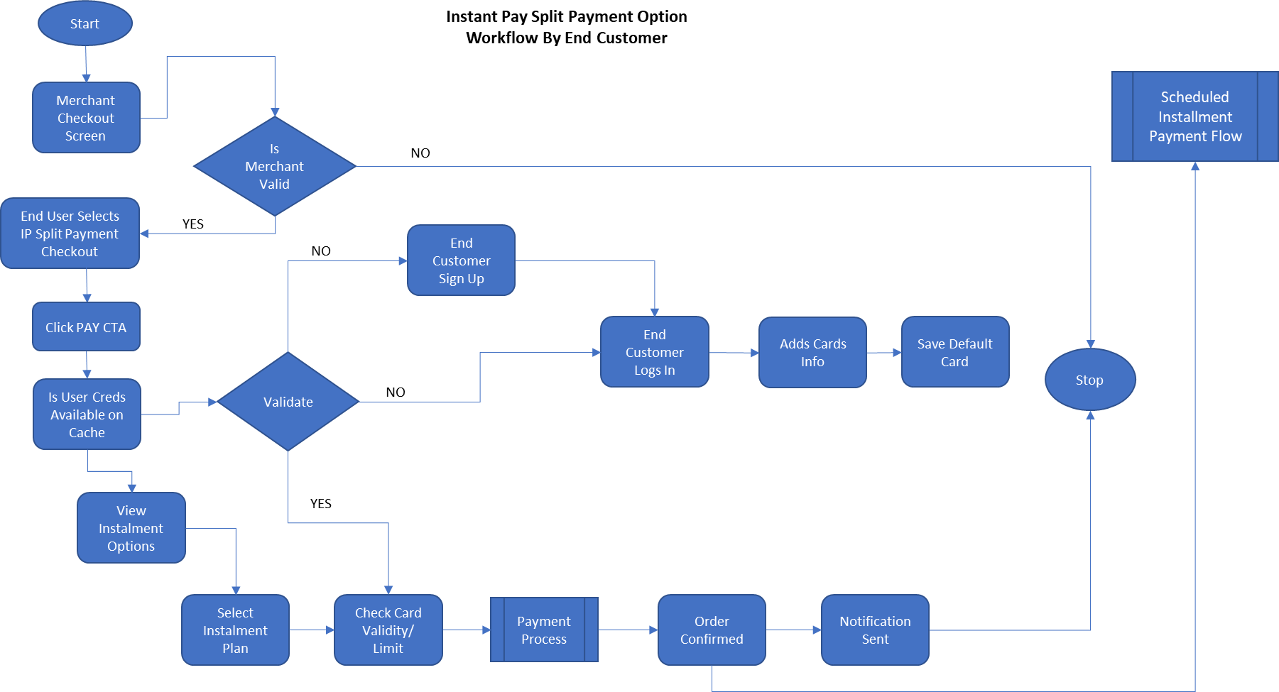

## Instant Pay Split Payment Option Process flow by End Customer

Step 1: Once user have selected the Instant Pay Split Payment Option using Merchant Checkout page after adding items to the cart

Step 2: The system will check if the Merchant is valid and the User is (Exist and Signed In / Need to Sign In / Need to Register and Sign In)

Already signed in to the Instant Pay payment portal and have chosen the option of “Keep Me Signed In for faster checkout” if this is validated, the user will immediately be redirected to the Instant Pay Portal URL where the User will view the Split Payment Option view where the user will be able to choose the desired Instalment amount and duration of the Split Payments required to be processed after clicking the Confirm Instalment CTA the user will be redirected to the Merchant Checkout page to confirm the order

**Marvel link :-** <https://marvelapp.com/prototype/94a8271/screen/74020693>

OR

The User is redirected to the Instant Pay Marketing Portal to Sign In and the User will need to enter the User ID and Password the user will immediately be redirected to the Instant Pay Portal URL where the User will view the Split Payment Option view where the user will be able to choose the desired Instalment amount and duration of the Split Payments required to be processed after clicking the Confirm Instalment CTA the user will be redirected to the Merchant Checkout page to confirm the order

**Marvel link :-** <https://marvelapp.com/prototype/94a8271/screen/74021004>

OR

The User is redirected to Instant Pay Marketing Portal and Register as a new user with the necessary information as mentioned in the Section 4.1 and User is than required to Login to the Instant Pay Interface and the Preferred Credit Card information to be stored on Instant Pay for future Transactions. user will immediately be redirected to the Instant Pay Portal URL where the User will view the Split Payment Option view where the user will be able to choose the desired Instalment amount and duration of the Split Payments required to be processed after clicking the Confirm Instalment CTA the user will be redirected to the Merchant Checkout page to confirm the order

Step 3: Once the payment has been processed the Success and Failure status of the transaction is shared via email to User and Notification will be sent to the Merchant Interface and User Interface and the record is inserted into the database for future reference and also for the payment schedules for the instalments that will be triggered during the scheduled dates for the future.

# Scheduled Jobs

## Scheduled Payment Authorization Flow

This process defines the payment authorization flow which is scheduled in the system to process the One Click Payment against a Transaction initiated by the user from the Merchant Portal

Step 1: Once the user initiates the Payment Confirmation the payment authorization job retrieves the user data from the database and runs the payment authorization Job which verifies if the transaction is valid or refunded or cancelled, If cancelled or refunded the process is ended.

Step 2: For valid transactions the payment is initiated via payment gateway and notification is sent to the Admin with the updated status and also the User and Merchant will be notified of the transaction via Email for the user and Interface Notification for Both User and Merchant

Step 3: Transaction record is than created in the database with the Merchant ID, Order ID and Transaction ID to update the relevant tables for the Admin, Merchant and User Interface

## Scheduled Instalment Payment Flow

This process defines the payment authorization flow which is scheduled in the system to process the Split Payment against a Transaction initiated by the user from the Merchant Portal

Step 1: Once the user initiates the Payment Confirmation the payment authorization job retrieves the user data from the database and runs the payment authorization Job which verifies if the transaction is valid or refunded or cancelled, If cancelled or refunded the process is ended.

Step 2: For valid transactions the payment is initiated via payment gateway and notification is sent to the Admin with the updated status and also the User and Merchant will be notified of the transaction via Email for the user and Interface Notification for Both User and Merchant

Step 3: Transaction record is than created in the database with the Merchant ID, Order ID and Transaction ID to update the relevant tables for the Admin, Merchant and User Interface

Step 4: The Database is updated with the user’s next instalment due and triggers the initiation of the payment by the next scheduled due date

# Marvel Links

## Instant Pay Admin Screens

|  |  |
| --- | --- |
| **Page Name** | **Marvel links** |
| Home Screen | <https://marvelapp.com/prototype/7d1j70b/screen/73312670> |
| Admin - Sign In | <https://marvelapp.com/prototype/7d1j70b/screen/73280094> |
| Admin - Forgot Password | <https://marvelapp.com/prototype/7d1j70b/screen/73508239> |
| Admin - Forgot Password - OTP popup | <https://marvelapp.com/prototype/7d1j70b/screen/73725486> |
| Admin - Forgot Password - OTP popup - Resend | <https://marvelapp.com/prototype/7d1j70b/screen/73725757> |
| Admin - Reset Password | <https://marvelapp.com/prototype/7d1j70b/screen/73280583> |
| Sign Up | <https://marvelapp.com/prototype/7d1j70b/screen/73358971> |
| Sign Up Form | <https://marvelapp.com/prototype/7d1j70b/screen/73425957> |
| Sign Up Form - Verify OTP | <https://marvelapp.com/prototype/7d1j70b/screen/73426957> |
| Sign Up Form - Resend OTP | <https://marvelapp.com/prototype/7d1j70b/screen/73427509> |
| Sign Up Form - OTP Verified | <https://marvelapp.com/prototype/7d1j70b/screen/73427212> |
| Admin - Dashboard | <https://marvelapp.com/prototype/7d1j70b/screen/73280651> |
| Admin - Dashboard - Reports dropdown open | <https://marvelapp.com/prototype/7d1j70b/screen/73494617> |
| Admin - Logout popover | <https://marvelapp.com/prototype/7d1j70b/screen/73282795> |
| Personal Information | <https://marvelapp.com/prototype/7d1j70b/screen/73509190> |
| Personal Information with Profile pic | <https://marvelapp.com/prototype/7d1j70b/screen/73509394> |
| Admin - Change Password | <https://marvelapp.com/prototype/7d1j70b/screen/73666377> |
| Admin - User Management | <https://marvelapp.com/prototype/7d1j70b/screen/73283239> |
| Admin - User Management - Filter | <https://marvelapp.com/prototype/7d1j70b/screen/73604537> |
| Admin - User Management Details | <https://marvelapp.com/prototype/7d1j70b/screen/73322652> |
| Admin - User Management Details - Merchant Details Popover | <https://marvelapp.com/prototype/7d1j70b/screen/73346970> |
| Admin - Add User popup | <https://marvelapp.com/prototype/7d1j70b/screen/73286961> |
| Admin - Edit User popup | <https://marvelapp.com/prototype/7d1j70b/screen/73287943> |
| Admin - Delete User popover | <https://marvelapp.com/prototype/7d1j70b/screen/73288670> |
| Admin - Merchant Management | <https://marvelapp.com/prototype/7d1j70b/screen/73309513> |
| Admin - Merchant Management - Filter | <https://marvelapp.com/prototype/7d1j70b/screen/73604982> |
| Admin - Merchant Management Details | <https://marvelapp.com/prototype/7d1j70b/screen/73346410> |
| Admin - Merchant Management Details - User Details popover | <https://marvelapp.com/prototype/7d1j70b/screen/73349906> |
| Admin - Add Merchant popup | <https://marvelapp.com/prototype/7d1j70b/screen/73310206> |
| Admin - Edit Merchant popup | <https://marvelapp.com/prototype/7d1j70b/screen/73310775> |
| Admin - Delete Merchant popover | <https://marvelapp.com/prototype/7d1j70b/screen/73311045> |
| Admin - Approve Merchant popover | <https://marvelapp.com/prototype/7d1j70b/screen/73311370> |
| Admin - Merchant Subscription Details popover | <https://marvelapp.com/prototype/7d1j70b/screen/73311471> |
| Admin - Settings | <https://marvelapp.com/prototype/7d1j70b/screen/73354170> |
| Admin - Settings - Payment Management | <https://marvelapp.com/prototype/7d1j70b/screen/73355643> |
| Admin - Settings - Payment Management - Refund popover | <https://marvelapp.com/prototype/7d1j70b/screen/73356755> |
| Admin - Settings - Payment Management - Refund Details popover | <https://marvelapp.com/prototype/7d1j70b/screen/73357742> |
| Admin - Settings - Subscription Management | <https://marvelapp.com/prototype/7d1j70b/screen/73391664> |
| Admin - Settings - Subscription Management - Delete popover | <https://marvelapp.com/prototype/7d1j70b/screen/73392758> |
| Admin - Settings - Subscription Management - Subscription Info popover | <https://marvelapp.com/prototype/7d1j70b/screen/73392866> |
| Admin - Settings - Subscription Management - Created By popover | <https://marvelapp.com/prototype/7d1j70b/screen/73393070> |
| Admin - Settings - Subscription Management - Add Subscription popup | <https://marvelapp.com/prototype/7d1j70b/screen/73393753> |
| Admin - Settings - Subscription Management - Edit Subscription popup | <https://marvelapp.com/prototype/7d1j70b/screen/73394418> |
| Admin - Settings - Email Template Management | <https://marvelapp.com/prototype/7d1j70b/screen/73398884> |
| Admin - Settings - Email Template Management - Add popup | <https://marvelapp.com/prototype/7d1j70b/screen/73399121> |
| Admin - Settings - Email Template Management - Add Content popup | <https://marvelapp.com/prototype/7d1j70b/screen/73601645> |
| Admin - Settings - Email Template Management - Edit popup | <https://marvelapp.com/prototype/7d1j70b/screen/73400102> |
| Admin - Settings - Notifications Template Management | <https://marvelapp.com/prototype/7d1j70b/screen/73402405> |
| Admin - Settings - Notifications Template Management - Add popup | <https://marvelapp.com/prototype/7d1j70b/screen/73402653> |
| Admin - Settings - Notifications Template Management - Edit popup | <https://marvelapp.com/prototype/7d1j70b/screen/73402934> |
| Admin - Settings - Roles & Permissions | <https://marvelapp.com/prototype/7d1j70b/screen/73429074> |
| Admin - Settings - Roles & Permissions - Add popup | <https://marvelapp.com/prototype/7d1j70b/screen/73429388> |
| Admin - Settings - Roles & Permissions - Edit popup | <https://marvelapp.com/prototype/7d1j70b/screen/73429657> |
| Admin - Reports - User Reports | <https://marvelapp.com/prototype/7d1j70b/screen/73490368> |
| Admin - Reports - User Reports dropdown open | <https://marvelapp.com/prototype/7d1j70b/screen/73491616> |
| Admin - Reports - Merchant Reports | <https://marvelapp.com/prototype/7d1j70b/screen/73491839> |
| Admin - Reports - Merchant Reports dropdown open | <https://marvelapp.com/prototype/7d1j70b/screen/73494116> |
| Admin - Settings - Instant Pay User Management | <https://marvelapp.com/prototype/7d1j70b/screen/73570033> |
| Admin - Settings - Instant Pay User Management - Add User popup | <https://marvelapp.com/prototype/7d1j70b/screen/73570659> |
| Admin - Settings - Instant Pay User Management - Edit User popup | <https://marvelapp.com/prototype/7d1j70b/screen/73571053> |
| Admin - Settings - Split Payment Management | <https://marvelapp.com/prototype/7d1j70b/screen/73580144> |
| Admin - Settings - Split Payment Management - Add popup | <https://marvelapp.com/prototype/7d1j70b/screen/73598269> |
| Admin - Settings - Split Payment Management - Edit popup | <https://marvelapp.com/prototype/7d1j70b/screen/73598427> |
| Admin - Settings - Content Management | <https://marvelapp.com/prototype/7d1j70b/screen/73718138> |
| Admin - Settings - Content Management - App Version | <https://marvelapp.com/prototype/7d1j70b/screen/73718526> |
| Admin - Settings - Content Management - App Version - Edit | <https://marvelapp.com/prototype/7d1j70b/screen/73719024> |
| Admin - Settings - Content Management - Social Media Links | <https://marvelapp.com/prototype/7d1j70b/screen/73722548> |
| Admin - Settings - Content Management - Terms & Conditions | <https://marvelapp.com/prototype/7d1j70b/screen/73786111> |
| Admin - Settings - Content Management - Terms & Conditions - Add New | <https://marvelapp.com/prototype/7d1j70b/screen/73787062> |
| Admin - Settings - Content Management - FAQ | <https://marvelapp.com/prototype/7d1j70b/screen/73787801> |
| Admin - Settings - Content Management - FAQ - Add New | <https://marvelapp.com/prototype/7d1j70b/screen/73788831> |
| Admin - Notifications | <https://marvelapp.com/prototype/7d1j70b/screen/74023568> |

## Merchant Screens

|  |  |
| --- | --- |
| **Page Name** | **Marvel links** |
| Home Screen | <https://marvelapp.com/prototype/94a8271/screen/73610261> |
| Contact Us | <https://marvelapp.com/prototype/94a8271/screen/74031707> |
| API Information | <https://marvelapp.com/prototype/94a8271/screen/74032778> |
| Merchant - Sign In | <https://marvelapp.com/prototype/94a8271/screen/73611291> |
| Merchant - Forgot Password | <https://marvelapp.com/prototype/94a8271/screen/73611608> |
| Merchant - Forgot Password - OTP popup | <https://marvelapp.com/prototype/94a8271/screen/73870270> |
| Merchant - Forgot Password - OTP popup - Resend | <https://marvelapp.com/prototype/94a8271/screen/73870498> |
| Merchant - Reset Password | <https://marvelapp.com/prototype/94a8271/screen/73612144> |
| Sign Up | <https://marvelapp.com/prototype/94a8271/screen/73612191> |
| Sign Up Form | <https://marvelapp.com/prototype/94a8271/screen/73612341> |
| Sign Up Form - Verify OTP | <https://marvelapp.com/prototype/94a8271/screen/73612528> |
| Sign Up Form - Resend OTP | <https://marvelapp.com/prototype/94a8271/screen/73612593> |
| Sign Up Form - OTP Verified | <https://marvelapp.com/prototype/94a8271/screen/73612707> |
| Merchant - Notification | <https://marvelapp.com/prototype/94a8271/screen/73665526> |
| Merchant - Dashboard Details | <https://marvelapp.com/prototype/94a8271/screen/73647664> |
| Merchant – Transaction History | <https://marvelapp.com/prototype/94a8271/screen/73643379> |
| Merchant - Sales Report | <https://marvelapp.com/prototype/94a8271/screen/73643536> |
| Merchant - Sales Report Filter | <https://marvelapp.com/prototype/94a8271/screen/73671783> |
| Merchant - Subscription | <https://marvelapp.com/prototype/94a8271/screen/73643631> |
| Merchant - Subscription payment | <https://marvelapp.com/prototype/94a8271/screen/73676657> |
| Merchant - Subscription Payment - Confirmation | <https://marvelapp.com/prototype/94a8271/screen/73950043> |
| Merchant - Subscription - Active Plan | <https://marvelapp.com/prototype/94a8271/screen/73676138> |
| Merchant - Subscription - Cancel Plan popup | <https://marvelapp.com/prototype/94a8271/screen/73988879> |
| Merchant - Subscription - Edit Plan | <https://marvelapp.com/prototype/94a8271/screen/73989416> |
| Merchant - Subscription - Active Plan | <https://marvelapp.com/prototype/94a8271/screen/73999122> |
| Personal Information | <https://marvelapp.com/prototype/94a8271/screen/73632101> |
| Personal Information with Profile pic | <https://marvelapp.com/prototype/94a8271/screen/73632179> |
| Merchant - Dashboard- Filter | <https://marvelapp.com/prototype/94a8271/screen/73631378> |
| Merchant - Logout | <https://marvelapp.com/prototype/94a8271/screen/73640596> |
| Merchant - Dashboard | <https://marvelapp.com/prototype/94a8271/screen/73613824> |
| Merchant - Settings | <https://marvelapp.com/prototype/94a8271/screen/74021494> |
| Merchant - Settings - Roles & Permissions | <https://marvelapp.com/prototype/94a8271/screen/74021719> |
| Merchant - Settings - Roles & Permissions - Add popup | <https://marvelapp.com/prototype/94a8271/screen/74021986> |
| Merchant - Settings - Roles & Permissions - Edit popup | <https://marvelapp.com/prototype/94a8271/screen/74022083> |
| Merchant - Settings - Merchant User Management | <https://marvelapp.com/prototype/94a8271/screen/74022227> |
| Merchant - Settings - Merchant User Management - Add User popup | <https://marvelapp.com/prototype/94a8271/screen/74022643> |
| Merchant - Settings - Merchant User Management - Edit User popup | <https://marvelapp.com/prototype/94a8271/screen/74022746> |

## End Customer Screens

|  |  |
| --- | --- |
| **Page Name** | **Marvel links** |
| Sign Up Form | <https://marvelapp.com/prototype/7dga270/screen/73912904> |
| Sign Up Form - Verfiy OTP | <https://marvelapp.com/prototype/7dga270/screen/73912961> |
| Sign Up Form - Resend OTP | <https://marvelapp.com/prototype/7dga270/screen/73913000> |
| Sign Up Form - OTP Verified | <https://marvelapp.com/prototype/7dga270/screen/73913046> |
| First Time User Logs In | <https://marvelapp.com/prototype/7dga270/screen/73836636> |
| User - Dashboard | <https://marvelapp.com/prototype/7dga270/screen/73635184> |
| User - Dashboard - Payment Details popover | <https://marvelapp.com/prototype/7dga270/screen/73642568> |
| User - Dashboard - Installments Details | <https://marvelapp.com/prototype/7dga270/screen/73643054> |
| User - Transactions | <https://marvelapp.com/prototype/7dga270/screen/73646148> |
| User - Notifications | <https://marvelapp.com/prototype/7dga270/screen/73647382> |
| User - Payment Details | <https://marvelapp.com/prototype/7dga270/screen/73667008> |
| User - Payment Details - Add popup | <https://marvelapp.com/prototype/7dga270/screen/73667614> |
| User - Payment Details - Edit popup | <https://marvelapp.com/prototype/7dga270/screen/73667816> |

## End Customer Payment Through Merchant Portal Screens

|  |  |
| --- | --- |
| **Page Name** | **Marvel links** |
| User Payment via Merchant - Payment Options | <https://marvelapp.com/prototype/94a8271/screen/73993324> |
| User Payment via Merchant - Instant Pay Payment Option | <https://marvelapp.com/prototype/94a8271/screen/73993530> |
| User Payment via Merchant - One Click - User Logged In | <https://marvelapp.com/prototype/94a8271/screen/74000643> |
| User Payment via Merchant - One Click - User Logged In - Order Confirmation popup | <https://marvelapp.com/prototype/94a8271/screen/74000750> |
| User Payment via Merchant - One Click - User Logged In - Order Confirmed | <https://marvelapp.com/prototype/94a8271/screen/74001978> |
| User Payment via Merchant - One Click - User Not Logged In | <https://marvelapp.com/prototype/94a8271/screen/74002219> |
| User Payment via Merchant - One Click - Invalid Merchant | <https://marvelapp.com/prototype/94a8271/screen/74003467> |
| User Payment via Merchant - Split Payment - User Logged In | <https://marvelapp.com/prototype/94a8271/screen/74020693> |
| User Payment via Merchant - Split Payment - User Logged In - Selected Option | <https://marvelapp.com/prototype/94a8271/screen/74020947> |
| User Payment via Merchant - Split Payment - User Not Logged In | <https://marvelapp.com/prototype/94a8271/screen/74021004> |